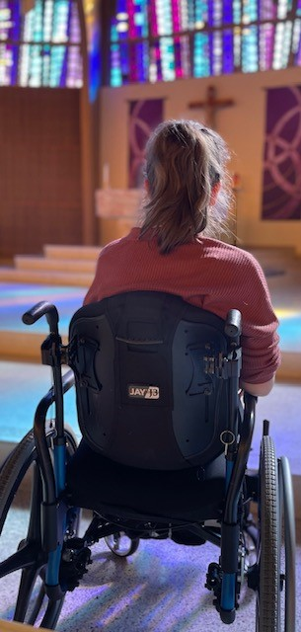
“Disabled individuals bring with them a special insight into the meaning of life, for they live - more than the rest of us, perhaps - in the shadow of the cross. And out of their experience they forge virtues such as courage, patience, perseverance, compassion and sensitivity that should serve as an inspiration to all Christians” (U.S. Catholic Bishops).

Why welcome all to Church? The Church aspires to be an inclusive environment. Individuals with disabilities, like everyone else, have the right to be at mass and be a part of the parish because of their Baptism, “Catholics with disabilities have a right to participate in the sacraments as fully as other members of the local ecclesial community” (U.S. Catholic Bishops).

What to expect? Some with disabilities may worship differently. They may make noises or flap their hands. They may have vocal tics or have a hard time sitting still. They still have the right to sit in the presence of Jesus. Any type of disability “Intellectual, physical or developmental disability doesn’t mean spiritual disability” (Sutton).

How to welcome people with disabilities?
- Treat a person with a disability as you would anyone else.
- Don’t stare, instead engage!
- Be friendly. Make eye contact.
- Address the individual, not a caretaker or family member.
- Remember to use language that is age-appropriate and respectful and appropriate to the setting (https://ncpd.org/).
- Treat adults with disabilities as adults rather than as children, regardless of the disability.
- Speak at a normal rate, without exaggeration or overemphasis.
- Do not be afraid to ask questions about the person’s disability.
- If someone uses a communication device – be patient - it may take them longer to process their response.
- Embrace the noise – for some it is their form of prayer. No need to turn or stare.
- Allow people to do things for themselves when they want to, even if it takes longer or results in mistakes. Do not always “do for” the person.
- Offer assistance but do not impose if help is not desired.
- Respect the individual’s personal space and auxiliary aids.
- Offer them the sign of peace - if they cannot shake hands; gently touch their shoulder or hand.

References

Catholic Bishops, U. S. (1998, August). Pastoral Statement of US Catholic Bishops on Persons with Disabilities. United States Catholic Conference, Washington D.C., United States.
Catholic Bishops, U. S. (2017, June). Guidelines for the Celebration of the Sacraments with Persons with Disabilities. United States Conference for Catholic Bishops, United States.
National Catholic Partnership on Disability. (n.d.). National Catholic Partnership on Disability. Retrieved September 22, 2021, from https://ncpd.org/
Persons with Disabilities in the Parish. (2000). Archdiocese of Wisconsin. https://catholicdos.org/
Sutton, L. R. (2013). How to Welcome, Include and Catechize Children with Autism and Other Special Needs. Loyola Press.

