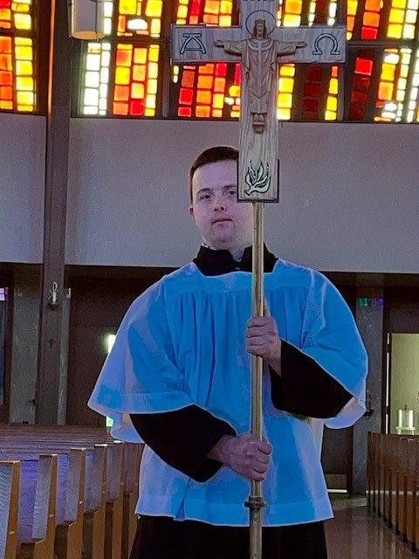
Celebrate A Mass Designed for Those with Disabilities
This mass should be held as often as possible to ensure everyone is included and welcomed in the Eucharistic Celebration. It could be held quarterly to start and builds from there to monthly or weekly.

Promote the Masses in the parish bulleting and Mass announcements leading up to the special Mass.
Prepare Congregation at the beginning of Mass
Begin with announcement –
“This mass is designed for all to participate. We will recite prayers and responses a little more slowly and we will pause after each line. The Priest may describe or add some teaching commentary during the mass. You may also hear noises and see more movement than usual; this may be a form of prayer for some individuals who are here. Musicians will keep the songs simple. This will allow everyone to fully engage in the Eucharist.

Include a Prayer for open-mindedness
Prayer for an Open Mind
Loving God,
I pray that you give me an open heart and an open mind
Help me to welcome those who are different from me into Your church
I pray that you use my curiosity for good
I pray that you give me the courage to want to learn and the wisdom to understand
I want to help my community grow in love charity and perspective
I desire to grow my relationship with you, my God, through helping others feel embraced in the church.
Amen
Prayers and Responses
- Recite prayers in a slower form so that everyone can easily participate. This looks like pausing after each line. Ensure priest and lector are loud and reciting at a slower pace. Having someone with a disability with the lector will give parishoniers a visual cue as well to slow down.
- Specifically, the Apostle’s Creed and The Our Father
- This allows for everyone to join in and even those who may use a communication device.
Music
- Keep songs simple and encourage singing and movement.
- Include those with disabilities in the choir.
- Announce - that it is ok to make noise or move around as this is a form of prayer for some with disabilities.

Sign of Peace
- Acknowledge everyone.
- Allow for more time for those who may need it.

Communion
- Make sure all Eucharistic Ministers are trained properly on how to administer the Eucharist to those with disabilities.
- If someone is in a wheelchair, come down to their wheelchair.
- Make eye contact
- If the Eucharistic minister is unsure if a person can receive communion ask the person whether they would like to receive the Eucharist by hand or by mouth.

www.thegoldenruleproject.org

